RAJAGIRI SCHOOL OF ENGINEERING
AND TECHNOLOGY
Rajagiri Valley, Kochi -39



RT 503 –DATA BASE MANAGEMENT SYSTEMS
MODULE I

Prepared by
Preetha K G

INDEX

Introduction to Database Systems
  - Basic Concepts
  - Disadvantages of File system
  - Advantages of DBMS
  - Functions of DBMS
  - Features of DBMS
  - Data Abstraction
  - Data Independence
  - Components of DBMS
  - DBMS Users
  - Structure of DBMS
  - Data Models
    - Object Based Logical Models
1.11.1.1 Entity Relationship Model
1.11.1.2 Object Oriented Model
    - Record Based Logical Models
1.11.2.1 Relational Model
1.11.2. 2 Network Model
1.11.2.3 Hierarchical Model
    - Physical Data Model
1.12 E-R Diagram

Introduction to Database Systems
  - Basic Concepts
A database is a collection of related data that we can query effectively and efficiently.

A Database Management System (DBMS) is a software package to facilitate the creation and maintenance of a computerized database. A Database System (DB) is a DBMS together with the data itself.

DBMS is a collection of interrelated data and a set of programs to access this data in convenient and efficient way. It controls the organization, storage, retrieval, security and integrity of data in a database. It accepts requests from the application and instructs the operating system to transfer the appropriate data.
New categories of data can be added to the database without disruption to the existing system. Constructing a database is the process of storing the data. New categories of data can be added to the database without disruption to the existing system. Processing of database is the manipulation of data in the database.
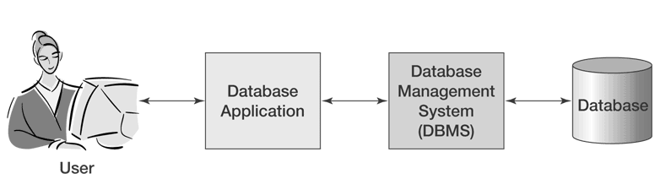
Database has the following properties.
- It should represent some aspect of the real world.
- It is a logical collection of data.
- It is designed, built and populated with data for a specific purpose.

Eg:, Student Database

The major DBMS vendors are Oracle, IBM, Microsoft and Sybase.

  - Disadvantages of File system
In the traditional file system the data is stored in different files. There is one application program for each application.
a) Difficulty in accessing information
Suppose a teacher needs a list of students from the student file whose mark greater than 500. But, we do not have an application to handle this request. In order to access this information either we have to develop a program to satisfy this new request or take the list of students from the file system and extract the list needed manually. These methods are very time consuming and difficult.
- Data redundancy and inconsistency
In file systems the data may be duplicated. Consider a bank having two accounts savings bank account and fixed account. Suppose a customer is having both accounts. In this case, the address of customer is stored in two account files. This duplication will result in need of high storage space. And this will also leads to the inconsistency. That is, if the address of a customer changes, then the change may be reflected only in one account.
- Data Isolation
Data are stored in different files and files are in different formats. So it is difficult extract the appropriate data from different files.
- Integrity problems
The constraint of data is added by means of programs. So if we need to add a new constraint, we have to change the code.
- Atomicity problems
If any failure occurs during execution of the program then the execution stops immediately. This leads inconsistency of data in the database.
f) Concurrent Access Anomalies
Concurrent updates may result in inconsistent data
g) Security Problems
Difficult to enforce security constraint because application programs are added to the system in an ad-hoc manner.
1.3 Advantages of DBMS
In a database system, the data is managed by the DBMS and all access to the data is through the DBMS providing a key to effective data processing. In conventional data processing systems each application program has direct access to the data it reads or manipulates.
In the conventional data processing application programs, the programs usually are based on a considerable knowledge of data structure and format. In such environment any change of data structure or format would require appropriate changes to the application programs. If major changes were to be made to the data, the application programs may need to be rewritten. In a database system, the database management system provides the interface between the application programs and the data. When changes are made to the data representation, the metadata maintained by the DBMS is changed but the DBMS continues to provide data to application programs in the previously used way. The DBMS handles the task of transformation of data wherever necessary.
- Redundancies and Inconsistencies can be reduced
In traditional file processing, every user group maintains its own files. Each group independently keeps files on their database. Therefore, much of the data is stored twice or more. This redundancy leads to several problems.
Storage space wasted when the same data is stored repeatedly. Files that represent the same data may become inconsistent since each user group updates the data independently.
- Better service to the Users
- Providing Persistent Storage for Program Objects and Data Structures
Data structure provided by DBMS must be compatible with the programming language’s data structures. E.g., Object oriented DBMS are compatible with programming languages such as C++, JAVA. DBMS software automatically performs conversions between programming data structure and file formats.
- Flexibility of the system is improved
- Cost of developing and maintaining systems is lower
- Standards can be enforced
- Security can be improved
DBMS provides a security and authorization. Some database users will not be authorized to access all information in the database (e.g., financial data). Some users are allowed only to retrieve data. Some users are allowed both to retrieve and to update database.
- Integrity can be improved
The integrity constraint for information is reasonably enforced by the database management system.
- Providing multiple user interface
- Permitting Inference and Actions Using Deduction Rules
Deductive database systems provide capabilities for defining deduction rules to inference new information from the stored database facts.
- Enterprise requirements can be identified
- Representing Complex Relationships Between Data
- Data model must be developed

Disadvantages of DBMS
A database system generally provides on-line access to the database for many users. Because of the larger number of users accessing the data when a database is used, the enterprise may involve additional risks as compared to a conventional data processing system in the following areas
a) Confidentiality, Privacy and Security
To reduce the chances of unauthorized users accessing sensitive information, it is necessary to take technical, administrative and, possibly, legal measures. Most databases store valuable information that must be protected against deliberate trespass and destruction.
b) Data Quality
Since the database is accessible to users remotely, adequate controls are needed to control users updating data and to control data quality. With increased number of users accessing data directly, there are enormous opportunities for users to damage the data. Unless there are suitable controls, the data quality may be compromised.
c) Data Integrity
Since a large number of users could be using a database concurrently, technical safeguards are necessary to ensure that the data remain correct during operation. The main threat to data integrity comes from several different users attempting to update the same data at the same time. The database therefore needs to be protected against inadvertent changes by the users.

d) Enterprise Vulnerability
Centralizing all data of an enterprise in one database may mean that the database becomes an indispensable resource. The survival of the enterprise may depend on reliable information being available from its database. The enterprise therefore becomes vulnerable to the destruction of the database or to unauthorized modification of the database.
e) The Cost of using a DBMS
Conventional data processing systems are typically designed to run a number of well-defined preplanned processes. In the conventional systems are usually inflexible in that new applications may be difficult to implement and/or expensive to run, they are usually very efficient for the applications they are designed for.
The database approach on the other hand provides a flexible alternative where new applications can be developed relatively inexpensively.
1.4 Functions of DBMS
- Create database, tables, and supporting structures
- Read and update database data
- Maintain database structures
- Enforce rules
- Control concurrency
- Provide security
- Perform backup and recovery
1.5 Features of DBMS
a) Data Security
The DBMS can prevent unauthorized users from viewing or updating the database. Using passwords, users are allowed access to the entire database or subset of database. For example, in an employee database, some users may be able to view salaries while others may view only work history and medical data.
b) Data Integrity
The DBMS can ensure that no more than one user can update the same record at the same time. It can keep duplicate records out of the database; for example, no two customers with the same customer number can be entered.

c) Interactive Query
Most DBMSs provide query languages and report writers so that users can interact the database and analyze its data. This important feature gives users access to all management information as needed.
d) Interactive Data Entry and Updating
Many DBMSs provides the users interactively enter and edit data. This allowing you to manage your own files and databases. However, interactive operation does not leave an audit trail and does not provide the controls necessary in a large organization. These controls must be programmed into the data entry and update programs of the application.
e) Data Independence
With DBMSs, the details of the data structure are not stated in each application program. The program asks the DBMS for data by field name; for example, a coded equivalent of "give me customer name and balance due" would be sent to the DBMS. Without a DBMS, the programmer must reserve space for the full structure of the record in the program. Any change in data structure requires changing all application programs.
f) Self describing
The database system contains not only the database itself but also a complete definition or description and structure of database. This structure is stored in a catalog with type, storage format and constraints as I mentioned earlier. The information stored in database is called meta-data.
  - Data Abstraction
To simplify the user’s interaction with the database system the developers hide the complexity of from users. So the database architecture is divided into three levels Physical, logical level and view level. The generalized architecture of DBMS is called ANSI/SPARC model.
a) External View or User View
It is the highest level of data abstraction. This is an individual user's view of the organization of the data. This includes only those portions of database of concern to a user or Application program. Each user has a different external view and it is described by means of a scheme called external schema. The schema contains the definition of the logical records and relationships in external view. It also contains the method of deriving the objects in the external view from the objects in the conceptual view.
b) Conceptual View/Logical View
This represents how the community views the organization of the data. At this level of database abstraction, all the database entities and the relationship among them are included. One conceptual view represents the entire database called conceptual schema. It describes what data are stored and what relation exists among those data. And also specify the checks to retain the data consistency and integrity.
c) Internal View/Physical View
It is the lowest level of abstraction, closest to the physical storage method. It describes how the data is stored, the structure of data storage and the method of accessing these data. It is represented by internal schema.

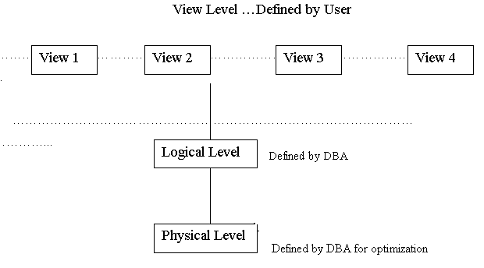

  - Data Independence
Data independence of DBMS is the capacity to change the schema at one level of database system without having to change the next high levels. The three-schema architecture can be used to achieve this data independence.
1. Logical data independence
It is the capacity to change the conceptual schema without having to change the external schema. Sometimes, we may need to change the conceptual schema to expand the database, to change the constraints, or to reduce the database. Only the view definitions and mappings need to be changed in DBMS that supporting logical data independence. Application programmer cannot feel any change in the schema construct of DBMS.
2. Physical data independence
Physical data independence is the capacity to change the internal schema without having to change the conceptual schema and external schema. The internal schema may change to improve the performance of retrieval or update. Then the conceptual schema need not change if the data remains same. For e.g.: We need not change the Query to retrieve a student progress report even though the DBMS take a new method to store the student record.
  - Components of DBMS
a) Data
Data stored in a database are basically divide into two categories numerical data such as integers or floating point numbers and non numerical data such as characters (alphabetic and numeric characters), date or logical (true or false). More advanced systems may include more complicated data entities such as pictures and images.
b) Standard Operations
Most of the DBMS provides standard operations like sorting, deleting and selecting records. The user can manipulate data using these operations.
c) Data definition language (DDL)
DDL is the language used to describe the contents of the database such as attribute names (field names), data types, location in the database, etc.
d) Data Manipulation and Query language
DBMS support query language provides the commands for input, edit, analysis, output, reformatting, etc. Some degree of standardization has been achieved with SQL (Structured Query Language).
DML are of two types
- Procedural DML
This requires a user to specify what data are needed and how to get those data.
- Non procedural DML
This requires a user to specify what data are needed without specifying how to get those data.
e) Programming tools
Besides commands and queries, the database should be accessible directly from application programs through function calls (subroutine calls) in conventional programming languages.
f) File structures
Every DBMS has its own internal structures used to organize the data and most of them used some common data models.
  - DBMS Users
- Application Programmers: Computer professionals who interact with the system through DML calls which are embedded in the program written in programming language.
- Sophisticated Users: Users who interact with the system without writing programs. They request the data through query language.
- Specialized Users: These are sophisticated users who write specialized database applications that do not fit into the traditional data processing framework.
- Naïve users: The user need not aware of the database system or any other system supporting.
- Database Administrator (DBA): A person who has central control of both data and programs for access those data is called DBA.
Functions of DBA
  - Set up the conceptual view of the database in consultation with the user.
  - Mapping different Levels
  - Defining procedures to recover database from failures
  - Granting permission to the users to access the database.
  - Schema definition
  - Integrity constraint specification

  - Structure of DBMS
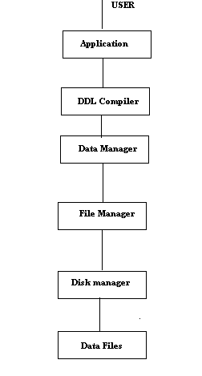
Data Manager: This is central software it converts the queries to a physical file enforcing constraints, backup, recovery etc.
File Manager: Control the structure of files and transmit when required.
Disk Manager: Is the Operating system of the host machine.
  - Data Models
Data modeling is the process of creating a logical representation of the structure of the database. This is the most important task in database development
A data model is a plan for building a database. The model represents data conceptually, the way the user sees it, rather than how computers store it. Data models focus on required data elements and associations most often they are expressed graphically using entity-relationship diagrams.
A data model is more generalized and abstract than a database design. It is easier to change a data model than it is to change a database design, so it is the appropriate place to work through conceptual database problems.
Three schema model
The Three Schema Model provides a framework describing the role and purpose of data modeling.
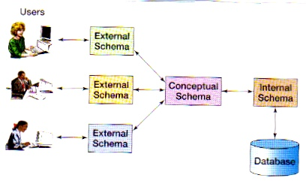
- External schema (or user view)
  - Representation of how users view the database
- Conceptual schema
  - A logical view of the database containing a description of all the data and relationships
  - Independent of any particular means of storing the data
  - One conceptual schema usually contains many different external schemas
- Internal schema
  - A representation of a conceptual schema as physically stored on a particular product
  - A conceptual schema can be represented by many different internal schemas

    - Object Based Logical Models
1.11.1.1 Entity Relationship Model
This is based on the perception of the real world that consists of a collection of basic objects called entities and the relationship among entities. Entity is a thing distinguishable from other objects. Relationship is the association among several entities. Each entity has its own properties called its attributes.
1.11.1.2 Object Oriented Model
Object DBMSs add database functionality to object programming languages. This is based on collection of objects. An object contains block of code called methods. One object can access data of another object is by invoking a method of that other object, by sending message to the object. A major benefit of this approach is the unification of the application and database development into a seamless data model and language environment. In this model applications require less code, use more natural data modeling, and code bases are easier to maintain.
1.11.1.3 Semantic Data Model
1.11.1.4 Functional Data Model
    - Record Based Logical Models
This is used in describing data at the logical levels. In this database is structured in fixed format records of several types. Each record type defines a fixed number of fields. Three models have been developed.
1.11.2.1 Relational Model
This uses collection of tables to represent both data and relationships. Each table has multiple columns and each column has a unique name.
Example:
Customer name | Address
John  Smith | Street1,EKM  Street5,KKND

1.11.2. 2 Network Model

In 1971, the Conference on Data Systems Languages (CODASYL) formally defined the network model. The basic data-modeling construct in the network model is the set construct. A set consists of an owner record type, a set name, and a member record type. A member record type can have more than one set; hence the multi parent concept is supported. An owner record type can also be a member or owner in another set. In network databases, a record type can have multiple owners.

In this model data are represented by collection of records and relationship among data are represented by links. Each record is a collection of fields (attributes).

Example:

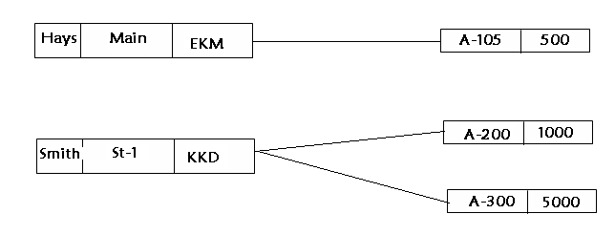

Advantages

• Network Model is able to model complex relationships and represents semantics of add/delete on the relationships.

• It can handle most situations for modeling using record types and relationship types.

• Language is navigational; uses constructs like FIND, FIND member, FIND owner, FIND NEXT within set, GET etc. Programmers can do optimal navigation through the database.

Disadvantages

• Navigational and procedural nature of processing

• Database contains a complex array of pointers that thread through a set of records.

• Little scope for automated "query optimization"
1.11.2.3 Hierarchical Model
The hierarchical data model organizes data in a tree structure. There is a hierarchy of parent and child data segments. This structure implies that a record can have repeating information, generally in the child data segments. Data are stored in a series of records have a set of field values attached to it. It collects all the instances of a specific record together as a record type. To create links between these record types, the hierarchical model uses Parent Child Relationships. In this records are linked together like an organization chart. Only one owner can own a record type.
Hierarchical structures were widely used in early mainframe systems.
Example:
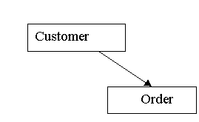
In the above example orders are owned by a single customer.
Advantages
• Hierarchical Model is simple to construct and operate on
• Corresponds to a number of natural hierarchically organized domains - e.g., assemblies in manufacturing, personnel organization in companies
• Language is simple; uses constructs like GET, GET UNIQUE, GET NEXT, GET NEXT WITHIN PARENT etc.

Disadvantages
- Navigational and procedural nature of processing
- Database is visualized as a linear arrangement of records
- Little scope for "query optimization"
- Data Inconsistency
- Wastage of Space
    - Physical Data Model
This describes data at the lower level. Examples are unifying model and frame memory model.
  - E-R Diagram
Entities are distinguishable objects and their characteristics are called attributes. A database usually contains large number of similar entities. An institution database consists of a large number of students may want to store similar information for each students. Then each of the students is an entity. An entity is an object with physical existence. But each entity will have its own value.
Example: employee, car, student etc.
Each entity has its own properties that describe the entity called attribute of that entity. Collection of entities with same attributes termed as an entity set.
Example: Employee (Employee_id, Address, Designation, Salary)
In this Employee is an entity and Employee_id, Address, Designation, Salary are the attribute of entity Employee.
Different types of attributes
- Composite versus Simple
Composite attributes are those attributes that can be divided into smaller sub parts with independent meaning.
In the above example the attribute Address can be divided into small sub parts like City, State and Street address etc.
The attributes that are not divisible are called simple or atomic attributes. The value of a composite attribute is the concatenation of the value of its constituent simple attributes.
- Single-valued verses multi-valued
Single valued attributes have only single value for a particular entity. Multi valued attributes having more than one value for an attribute of a particular entity.
Example: The attribute age of an entity person will have only one value, while the college degree of that person will have more than one degree. The attribute age is the single-valued attribute and college degree is multi-valued attribute.
- Stored verses derived
If the attribute values can be derived from the other is called derived attribute. Example: Consider a person as an entity. The attributes age and Date Of Birth of person is related. The age of a person can be derived from the current date and his Date Of Birth. In this example age is the Derived attribute and the Date Of Birth is the stored attribute from where age of person calculated.
- Null Attribute
An entity does not have a value.
Example: IF an employee has no dependent then it will be NULL.
A relationship is an association among several entities. A relationship set is a set of relationships of the same type. Relationship set is the set of relationship of the same type. Number of entities to which another entity that can be associated is called cardinality ratio or Mapping cardinalities.
Different types of Mapping
- One: One(1:1 ) : An entity set A is associated with at most one entity in set B and entity set B is associated with at most one entity in set A.
- One: Many(1: M): An entity set A is associated with any number of entities in set B and entity set B is associated with at most one entity in set A.
- Many: One(M:1): An entity set A is associated with at most one entity in set B and entity set B is associated with any number of entities in set A.
- Many: Many(M:M): An entity set A is associated with any number of entities in set B and entity set B is associated with any number of entities in set A.
Conceptually the individual entities and relationships are distinct. In a database perspective, the difference must be expressed by their attributes. The concept of key is used to make such distinctions.

Different types of keys
Super key is a set of attributes that, taken collectively, to identify uniquely an entity in the entity set. For eg: the social_security_no attribute of the entity set employee is sufficient to distinguish one employee entity from another. Thus social_security_no is a superkey for the entity set employee.
Candiadate key: Superkeys with minimal subset is known as the candidate key. For eg: it is possible to combine the attributes, employ_id & employ_name form a superkey. But the social_security_no is sufficient to distinguish the two employees. Thus social_security_no is a candidate key.
Primary key is used to denote the candidate key that is chosen by the database designer to identify an entity from an entity set.
A key (super, candidate and primary) is a property of the entity set rather than the individual entities.
E-R Diagram

The overall logical structure of a database can be expressed graphically by using an E-R diagram.
The diagram consists of the following major components.
- Rectangles: represent entity set.
- Ellipses: represent attributes.
- Diamonds: represents relationship sets.
- Lines: links attribute set to entity set and entity set to relationship set.
- Double ellipses: represent multi-valued attributes.
- Dashed ellipses: represent derived attributes.
Example: Consider an E-R diagram, which consists of two-entity sets employee and company
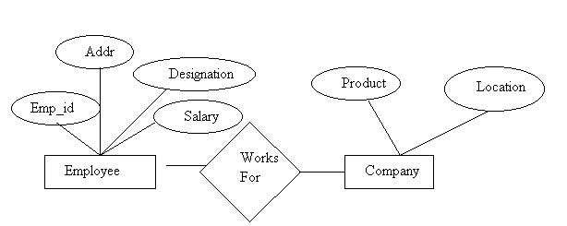Weak Entity Set
An entity set may not have sufficient attributes to form a primary key is called weak entity set.
An entity set that has a primary key is termed as a strong entity set.
The discriminator of a weak entity set is a set of attributes that allows the distinction of entities to be made.
Primary key of the weak entity set is formed by the primary key of the strong entity set on which the weak entity set is dependent plus the weak entity set’s discriminator.
Weak entity set is represented in the E-R diagram by using a doubly outlined box. And the relationship is represented in the doubly outlined diamond.
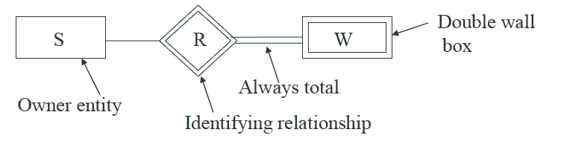
Extended E-R Features
- Specialization
The process of designating sub groupings within an entity set is called specialization.
- Generalization
Inversion of Specialization. Common attributes are represented by generalization. Number of entity sets share common features.
- Attribute Inheritance
The attributes of the higher level entity set are said to be inherited by the lower level entity sets.
Reduction of E-R diagrams into Tables
- Strong entity set
Let E be the entity set with attributes a1,a2,….an. then table contains n columns represent n attributes. Each raw represent one entity of E.
- Weak entity set
Let A be the weak entity set with attributes a1,a2,….an. let B be the strong entity set on which A is dependent. Let primary key of B is b1, b2,….bn. Tble contains column (a1,a2,…an)U(b1,b2…bn)
- Relationship set
Let R be the relationship and a1, a2…an be the attributes. Column represents attributes.
- Multi-valued attributes
Each value of attributes represents one raw.
- Generalization
Create a table for the higher level entity set. For each lower level entity set, create a table that includes a column for each of the attributes of that entity set plus a column for each attributes of the primary key of the higher level entity set.

